***Understanding corporate culture and leadership skills***

What is Cultural Leadership ?

Cultural leadership is the act of leading the cultural sector. Like culture itself, it comes from many different people and can be practised in many different ways. It concerns senior managers and directors in subsidized cultural institutions; public officials developing and implementing policy for the cultural sector; and a huge range of producers, innovators and entrepreneurs in small companies, production houses and teams. In the cultural world, nobody has a monopoly on leadership. Leading the cultural sector is practised in two different ways. First, it concerns competently managing the organisations of the cultural sector, ensuring that they are financially viable, legal and with well-organised staff. Second, it means leading culture itself - making work, productions and projects which show different ways of thinking, feeling and experiencing the world - bringing dynamism to the economy and wider society. Many of the challenges that cultural leaders need to navigate are common to those faced by leaders in other areas of social and economic life. How to stay solvent in an ongoing financial crisis. How to engage with digitally connected, networked individuals. How to work in less carbon intensive, environmentally sustainable ways. But cultural organisations are different from other organisations and as such face their own distinctive challenges

***Challenges :***

Cultural organisations are geared towards producing new ideas. It is their production of these new ideas as performances, exhibitions, styles and sounds which makes them cultural. Balancing this priority, with the need to run a financially sustainable organisation and hopefully one that makes a positive difference to the world, is which gives cultural leaders a unique set of challenges. Here are some of them.

*Describing value*

Unlike business leaders who can point to the bottom line, or leaders of charities who can measure their impact against a clearly defined social problem - leaders in the cultural sector face a constant struggle to explain and communicate the value of what they do. This task is made harder because the ideas cultural organisations produce are nonreplicable. Because they canʼt produce the same play, song or installation over and over again, they have to inspire confidence in projects without precedent or known outcomes.

*Working in networks*

Ideas thrive in loose networks rather than rigid structures, so cultural leaders have to too. This is why cultural leaders donʼt have to be at the head of big organisations to be important. Rather they often need to simultaneously operate in small companies, production houses and as loan-agents while being connected to rich and diverse networks of supporters, funders and collaborators. There is a complicated balance for cultural leaders to maintain.

*Living dangerously*

Cultural sector leaders often have to place themselves in danger. The best cultural organisations produce ideas that make new ways of seeing, thinking and feeling possible - their work is an expression of human freedom. This can be a benign, quiet act, but it can often threaten vested interests and powerful elites - especially in illiberal political regimes and places where giant corporation hold

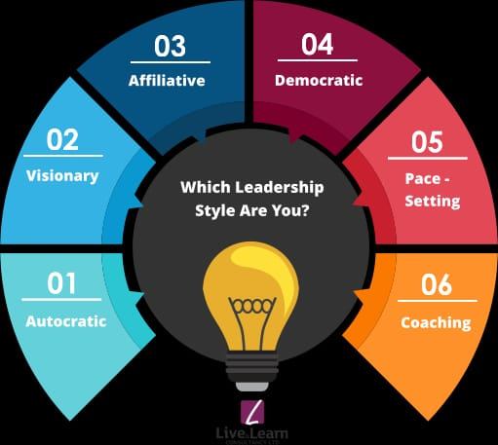

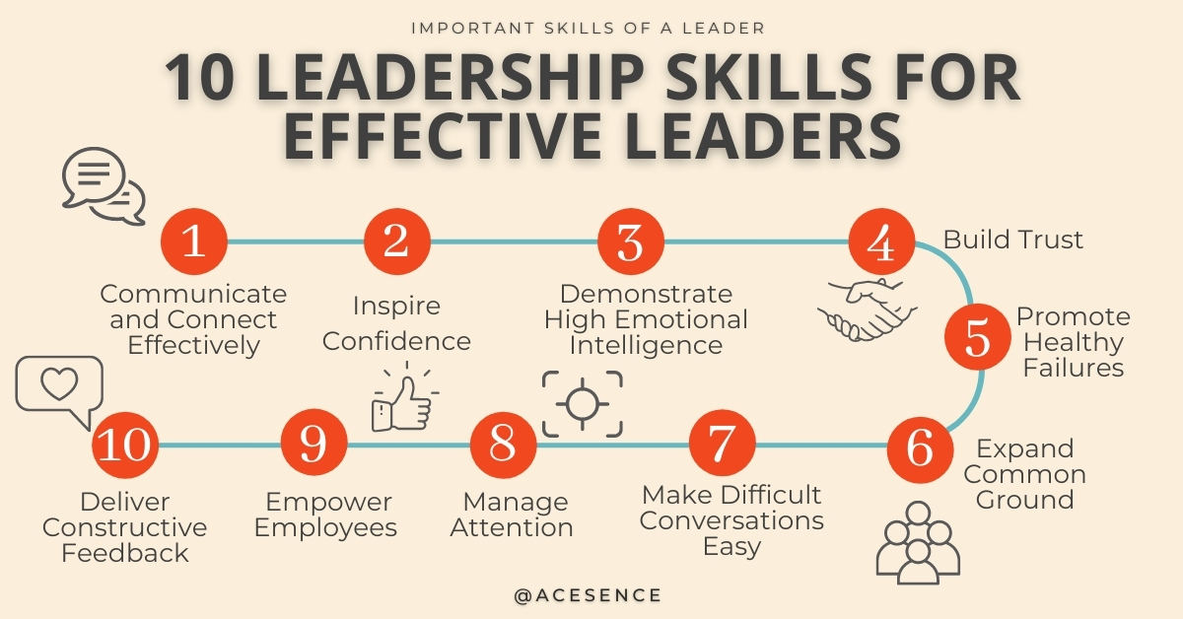

*Difference between leader and manager’s*

|  |  |
| --- | --- |
| Leader | Managers |
| * Concerned with the present | * Look to the future |
| * Make sure details are token care of | * . Set broad purposes and directions |
| * .Exercise control to make sure that things work well | * .Create a better future by seizing opportunities stimulated by changing events |
| * Solve today’s problem behavior by addressing difficulties caused by changing events | * Focus on the product |
| * Focus on process | * Focus on what is right and praise it |
| * Focus on problems behavior and try to improve it through counselling,coaching, and nurturing to | * Go beyond the need for standard procedures and create a more efficient system |
| * Make sure people put in an honest day’s work for their pay | * Create the vision of the years down the road |
| * Organize and plan to meet this year’s objectives | * Focus effectiveness |

***Prepare a speech as a leader***

The most important quality of good leader is good communication skills with good communication skills he can easily explain his plan to his peers

The art of thinking is an essential quality of good leaders with this quality the leader can look at the situation and think for ahead about the consequence of this situations and how it can be rectified A good leader does not panic when small problem arises but solves it thoughtfully